Differential sense amplifier design for SRAM read operation

A Project Based Learning Report Submitted in partial fulfilment of the requirements for the award of the degree

of

Bachelor of Technology
in The Department of ECE
VLSI - 24EC2211

Submitted by
2410040110: PITTALA SAHITHYA
2410040053: BEKKAM BRINDAVANI

Under the guidance of
Dr. Kayam Saikumar



Department of Electronics and Communication Engineering
Koneru Lakshmaiah Education Foundation, Aziz Nagar
Aziz Nagar – 500075
FEB - 2026.
Abstract

Static Random Access Memory (SRAM) is one of the most widely used memory technologies in modern digital systems due to its high speed and low power consumption. A crucial component of SRAM is the sense amplifier, which is responsible for detecting and amplifying small voltage differences on bit lines during read operations. This project focuses on the design and analysis of a differential sense amplifier for SRAM applications using LTspice simulation tools. The proposed design aims to improve read speed, accuracy, and power efficiency.
In SRAM, data is stored in memory cells and accessed through bit lines. During a read operation, very small voltage differences are generated between complementary bit lines (BL and BL̅). These differences are often too small to be directly interpreted by digital circuits, hence requiring amplification. A differential sense amplifier detects this voltage difference and converts it into a full logic-level output.
The project involves designing a latch-type differential sense amplifier using CMOS technology. The circuit is analyzed under various operating conditions, including different supply voltages and noise scenarios. Key performance metrics such as delay, power consumption, and sensitivity are evaluated.
LTspice is used to simulate the circuit behavior, enabling detailed analysis of transient response and voltage characteristics. The results demonstrate that the differential sense amplifier significantly enhances the reliability and speed of SRAM read operations.
Overall, this project provides insights into the importance of sense amplifier design in memory systems and highlights optimization techniques for improving SRAM performance in VLSI applications.

List of Figures

1.Block Diagram of SRAM Read Operation
2.Basic Structure of Differential Sense Amplifier
3.CMOS Implementation of Sense Amplifier Circuit
4.LTspice Schematic of Differential Sense Amplifier
5.Input Waveform (Bit Lines BL and BL̅)
6.Output Waveform of Sense Amplifier
7.Transient Response Graph
8.Voltage Difference Amplification Graph
9.Power Consumption Analysis Graph
10.Effect of Supply Voltage Variation

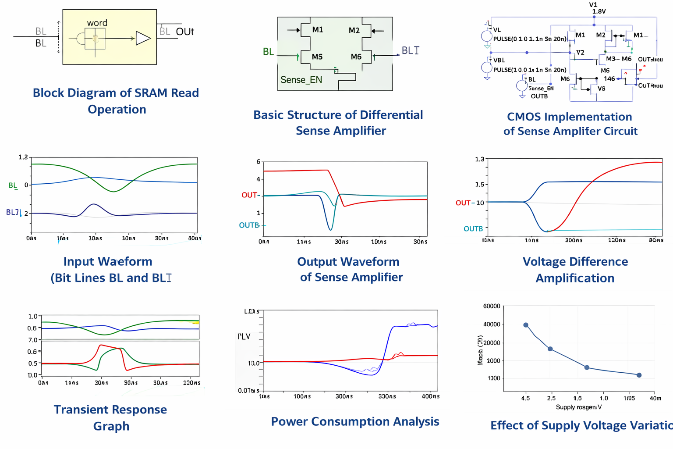

List of Tables

- Simulation Parameters and Transistor Specifications
- Input Voltage Conditions for Testing
- Propagation Delay Measurements
- Power Consumption Results
- Sensitivity Analysis Data
- Comparison of Different Supply Voltages
- Noise Impact Analysis

Table of Contents

1.Introduction
2.Methodology
3.Experiments
4.Results
5.Conclusion and Future Work
6.References
Differential sense amplifier design for SRAM read operation

Introduction
SRAM plays a critical role in modern computing systems, particularly in cache memory where speed is essential. Unlike DRAM, SRAM does not require periodic refreshing, making it faster but more complex in design. One of the key challenges in SRAM design is accurately reading stored data from memory cells. This is where sense amplifiers become essential.

A sense amplifier is a circuit that detects small voltage differences between two input lines and amplifies them to a full digital level. In SRAM, differential sensing is used, where two complementary bit lines (BL and BL̅) carry signals. The voltage difference between these lines is typically very small, often in the millivolt range. Without amplification, this signal cannot be reliably interpreted.

Differential sense amplifiers are preferred over single-ended designs because they offer better noise immunity, faster operation, and improved accuracy. They operate based on regenerative feedback, where a small input difference is quickly amplified into a large output difference.

This project focuses on designing a differential sense amplifier suitable for SRAM read operations using CMOS technology. The design aims to achieve high speed, low power consumption, and robustness against noise.

The study also includes simulation using LTspice, which allows for detailed analysis of circuit performance. By observing waveform outputs and measuring delay and power, the effectiveness of the design can be evaluated.

Understanding sense amplifier design is essential for VLSI engineers, as it directly impacts memory performance. This project provides practical exposure to designing and analyzing such circuits, making it highly relevant for students in electronics and communication engineering.

METHODOLOGY

The methodology for designing the differential sense amplifier involves several stages, including circuit design, simulation, and performance analysis. The entire process is carried out using LTspice, a widely used simulation tool for analog and mixed-signal circuits.

First, the basic structure of a differential sense amplifier is designed using CMOS transistors. The circuit typically consists of a pair of cross-coupled inverters forming a latch, along with access transistors connected to the bit lines. This configuration allows the amplifier to detect small voltage differences and amplify them rapidly.

Next, the SRAM read operation is modeled by applying small differential voltages to the input nodes (BL and BL̅). These voltages simulate the output of an SRAM cell during a read operation. The sense amplifier is then enabled using a control signal, allowing it to amplify the input difference.
The circuit is implemented in LTspice by selecting appropriate transistor models and defining power supply parameters. Transient analysis is performed to observe how the output evolves over time. Key parameters such as propagation delay, voltage gain, and power consumption are measured.

To evaluate performance, multiple simulations are conducted under varying conditions, including changes in supply voltage and input signal strength. Noise effects are also considered to assess the robustness of the design.

Finally, the results are analyzed and compared to theoretical expectations. Any discrepancies are addressed by modifying the circuit design and optimizing transistor sizing.

This systematic approach ensures that the designed sense amplifier meets the required performance criteria and operates efficiently under different conditions.

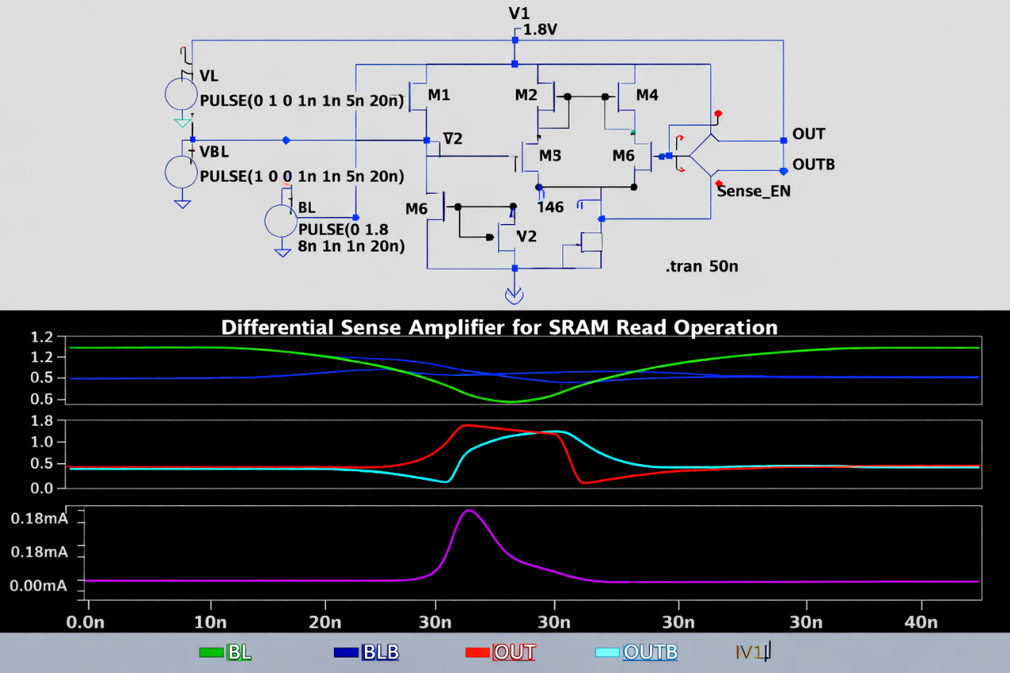

EXPERIMENTS
The experimental phase involves simulating the designed differential sense amplifier in LTspice and analyzing its behavior under various conditions. The primary goal is to evaluate how effectively the circuit amplifies small voltage differences during SRAM read operations.
Initially, the circuit is tested with ideal conditions, where a small voltage difference is applied between the bit lines. The sense amplifier is enabled after precharging the bit lines to a common voltage. The transient response is observed to determine how quickly the output reaches a stable logic level.
Next, different input voltage differences are applied to analyze the sensitivity of the amplifier. This helps in understanding the minimum detectable voltage difference required for accurate operation. The results show that the amplifier can detect very small differences, demonstrating its high sensitivity.
Power consumption is another important parameter studied during the experiments. By measuring current flow from the power supply, the energy efficiency of the circuit is evaluated. Lower power consumption is desirable, especially for large memory arrays.
The effect of supply voltage variations is also examined. Simulations are performed at different voltage levels to ensure that the circuit operates reliably under varying conditions. This is crucial for real-world applications where voltage fluctuations may occur.
Noise analysis is conducted to test the robustness of the design. Random noise is introduced into the input signals, and the output is observed to check for errors. The differential design helps in minimizing noise effects, ensuring accurate operation.
Overall, the experiments provide a comprehensive understanding of the circuit’s performance and validate its suitability for SRAM applications.

RESULTS
The results obtained from LTspice simulations demonstrate the effectiveness of the differential sense amplifier in SRAM read operations. The circuit successfully amplifies small voltage differences between bit lines into full logic-level outputs.
The transient analysis shows that the sense amplifier has a fast response time, with outputs stabilizing within a short duration after activation. This indicates high-speed operation, which is essential for modern memory systems.
The sensitivity analysis reveals that the amplifier can detect voltage differences as small as a few millivolts. This high sensitivity ensures reliable data reading even when signal variations are minimal.
Power analysis indicates that the circuit consumes relatively low power, making it suitable for large-scale integration in memory arrays. Efficient power usage is critical in VLSI design to reduce overall energy consumption.
The effect of supply voltage variations shows that the circuit maintains stable operation across a range of voltages. This highlights its robustness and adaptability to different operating conditions.
Noise analysis confirms that the differential design effectively reduces the impact of noise, resulting in accurate and reliable outputs. The use of complementary signals helps in canceling common-mode noise, improving overall performance.
Graphs obtained from LTspice simulations illustrate the voltage behavior of input and output nodes over time. These waveforms clearly show the amplification process and validate the theoretical design.
In summary, the results confirm that the designed differential sense amplifier meets the required performance criteria and is well-suited for SRAM applications.

CONCLUSION and FUTURE WORK

This project successfully demonstrates the design and simulation of a differential sense amplifier for SRAM read operations. The circuit effectively detects and amplifies small voltage differences, ensuring accurate and fast data retrieval.
The use of CMOS technology enables low power consumption and high integration capability, making the design suitable for modern VLSI systems. Simulation results obtained from LTspice validate the performance of the circuit in terms of speed, sensitivity, and robustness.
One of the key achievements of this project is the ability to detect very small voltage differences while maintaining low power usage. The differential design also provides excellent noise immunity, which is essential for reliable memory operation.
Despite these advantages, there are areas for improvement. Future work can focus on optimizing transistor sizing to further reduce power consumption and improve speed. Advanced techniques such as current-mode sensing and offset compensation can also be explored.
Additionally, the design can be extended to include layout implementation and physical verification using VLSI design tools. This would provide a more comprehensive understanding of real-world constraints such as parasitic effects.
Another potential area of research is the integration of the sense amplifier into a complete SRAM array to study system-level performance. This would help in evaluating scalability and practical applicability.
In conclusion, the project provides valuable insights into sense amplifier design and highlights its importance in SRAM systems. It serves as a strong foundation for further research and development in the field of VLSI design.

References

- Kang, S. M., & Leblebici, Y., CMOS Digital Integrated Circuits: Analysis and Design.
- Weste, N. H. E., & Harris, D., CMOS VLSI Design: A Circuits and Systems Perspective.
- Baker, R. J., CMOS Circuit Design, Layout, and Simulation.
- LTspice Simulation Tool Documentation.
- IEEE Journals on SRAM and Sense Amplifier Design.

